CERAMICS 1 NAME PLAQUE Name ______________________________

Begin by impressing, scratching and adding textures, patterns and designs to a flat SLAB of clay. You can cut it into a shape and add holes for hanging it.
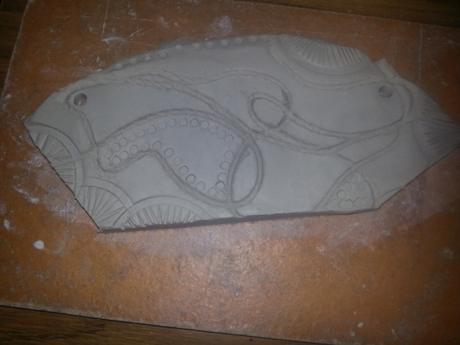

Form your letters out of more clay. SLIP and SCORE using a needle tool (or a pencil) and SLIP, this will securely adhere them!
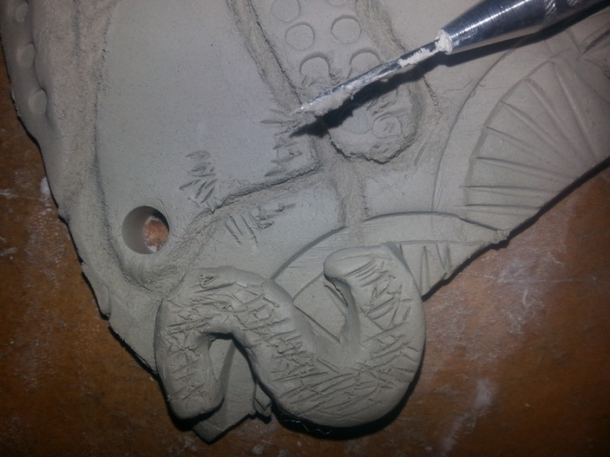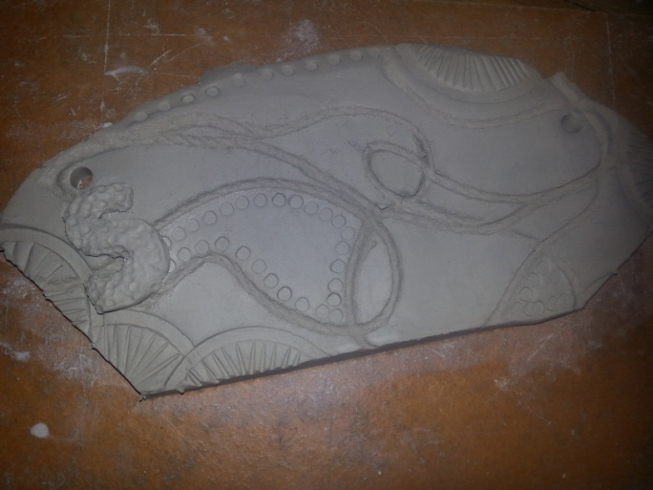
Later you can add more clay forms, like balls and spirals. We will then BISQUE fire it in the kiln. After that we will use GLAZES to add color, and see what the different glazes do on the textures.
Sketch your idea/plan here

